Name: | Neilburg School Community Council
Mailing Address | Box 309 Neilburg, SK S0M 2C0

Meeting Date: | Oct 6/22
Meeting Called to Order: | 7:51
Date of Next Meeting: | Nov 7/22 @ 3:30
Meeting Adjourned: | 8:52pm

Attendees:
Y | N | Brooke Forbes | Y | N | Sarah Hein
Y | N | Sara Goodfellow | Y | N | Stacey Mills
Y | N | Bev Nattress | Y | N | Rachel Wightman
Y | N | Ria Wiens | Y | N | Ashley Weinkauf
Y | N | Riki-Lee Weinkauf | Y | N | Charmaine Gonzales
Y | N | Principal- Roxanne Reynoldson | Y | N | Teacher Representative- Candice Steveson
Y | N | Student Representative- Justine Nattress

Meeting Agenda Items
Y | N | Secretary Report: Sarah presented
Y | N | Financial Report: Bev presented
Y | N | Principal Report: Roxanne presented
Y | N | Old Business
Y | N | New Business
Y | N | Other:

Topic | Discussion | Action Taken or Proposed | Person Responsible | Target  Date
Reports
Secretary Report | Sarah presented the Secretary report from May 4th and adopted to move minutes as read. Sara 2nd | All in Favour
Treasurer Report | Bev presented Treasurer report.  School Acct $1680.95  Division Acct $6872  Bev adopted to move report as read. Sarah 2nd | All in Favour
Principal Report | - 4 volleyball teams- 2 Junior, 2 Senior  - Junior Boys will be hosting conferences on Oct 27th, winners will move on to Districts  - Cross Country team attending meets  - Grade 1 class looking for volunteers to read with kids on Friday afternoons, spread the word  - Weekly assemblies on Monday at 9:00  - Monthly Celebration Assemblies- students awarded with Grit and Grace, and Athlete of the Month  - Data Tracking-  - Behavior slips are being tracked and after the 3rd slip the parents will be notified  - Thinking sheets in the office for the student to write down how they are feeling and are able to release so steam.  - Monthly Staff Meetings on the 3rd Monday of every month  - The Staff has created a Book club, they are reading Limitless right now  - The booth is back up and running. Riki asked if there is a way for the younger elementary kids to get help with the booth.  - School esthetics  - Exterior painting is still on the top 5, colours have been picked.  - The back compound has been reported and needs to be cleaned up.  - The roof is complete, flashing will be finished  - The School Board is coming for a tour Oct 20th at 2:30.  - We have 2 new permanent EA’s- Tammy Moir, and Kailey Burke.  - Grad is June 10th  - RCMP Liaison is Cst Michaela Woodrow  - Newsletters will be coming out 2nd Wednesday of every month  - Try a Trade is Nov 30th in North Battleford  - Grade 9/10 go as classes  - Grade 11/12 go as interested.  - School Learning Improvement Plan will be shared at the next meeting when it is complete.  - Goals are Literacy, Math, and Mental Health  - Oct 17-22 is Education week, book fair is also during this week, and Oct 17th is Bus Driver Appreciation Day  - SRC is having a Halloween Carnival from 2-4:00 | Roxanne to bring up at next staff meeting. A cart used to go down to the elementary end. Will think of some way to provide support to the younger students.
Old Business
Highschool Girls Bathroom | Bathroom doors are painted and hung. We will come up with some vinyl options and let the each Grade (7-12’s) vote on one door design each  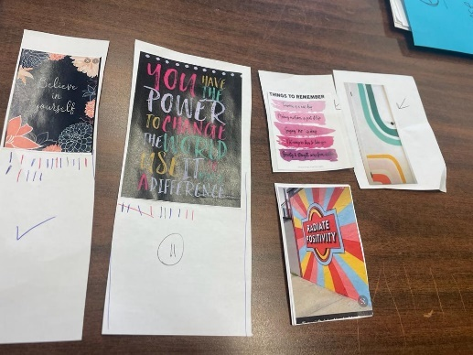 | Joanne gave us a quote for 4 colours and 4 doors would cost $220 + tax. Sarah made a motion we ask her to do all 6 doors with a $400 budget. Ashley 2nd. All in favour. | Sara to make arrangements with Joanne | Dec 31/22
Back to School BBQ | BBQ was another success | We will continue with this as it is well received!
Hot Lunches | Oct 11/25 we are doing Subway Hot lunches. | Bev will pick up Oct 11, and Amy Herbert has volunteered Oct 25th.
Nutrien Fundraisers | We sold 38 of the 60 bags of fertilizer.  Ruby approached us about selling the Bear Trax Ice melt. We can continue on with these two as a continuous fundraiser. | Everyone get the money you were paid into Kara.  Sarah to get the details from Ruby regarding Bear Trax.  Sara to put into the newsletter and Ashley to advertise on Facebook. | All  Sarah Hein  Sara G/ Ashley | Nov 7  Oct 12  Oct 12
New Business
School Dance | Ashley proposed we host a School Dance. Aim for Nov/Dec. | - Ria got in touch with Maz Entertainment. $1100 includes 2 DJ’s, lights and runs for 4 hours. And they will still honour the discount they were offering in September.  - They are booked for Dec 8th from 6:30-10:30pm.  - Charge $5 to get in to help recover some of the costs.
Breakfast Program | Life Skills is doing baking for the Breakfast program. Mr Wilson is organizing it. | Donations welcome.

